**UML - User Case Diagram:**

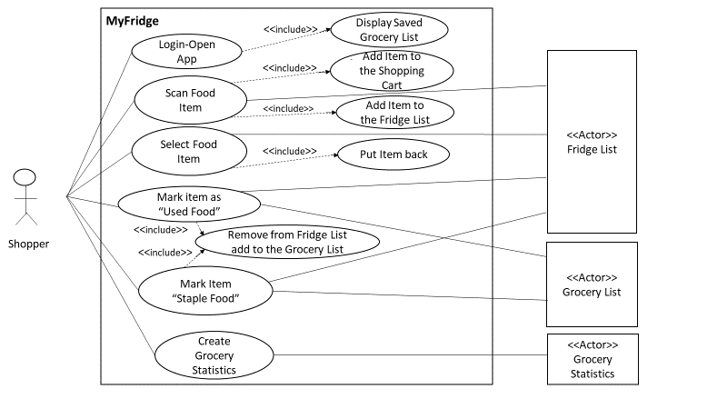

**User Case Description:**

UC1: Login-Open App – Shopper opens the Fridge application. System displays the grocery saved list.

UC2: Scan Food Item - Shopper scans food item barcode. System adds the scanned item into the shopping cart and to the fridge list.

UC3: Select Food Item - Shopper selects food item. System puts the selected item back. System removes the selected item from the fridge list without adding it to the grocery list.

UC4: Mark item as used food - Shopper mark an item as used food. System removes it from the fridge list and adds it to the grocery list or deletes it. System displays the updated fridge and grocery list.

UC5: Mark Item “Staple Food” - Shopper swipes to the next page and mark an item as a staple food. System removes the staple food from the fridge list and adds it to the grocery list. System displays the updated fridge and grocery list.

UC6: Create Grocery Statistics - Shopper creates grocery statistics. System categorizes food and provides shopping data including item, cost and time.